**How to adjust the probe sensitivity**

**Note: This instruction is used to adjust the sensitivity for the probe.**

1. **Power off the instrument at first. Then open the probe arm Cover.**

**Note: There is no screw to fix the probe arm cover.**

1. **Please adjust the potentiometer on the liquid level board, and you can measure the resistance on the 2 point (Marked in Red Blank).**

**Two Measuring Point**

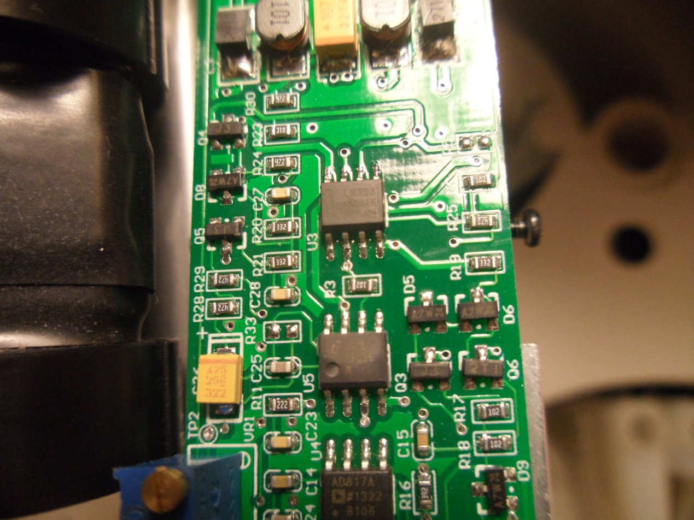

**Normally, the Resistance is around 150K between 2 measuring points. The lower the resistance is, the lower the probe sensitivity is.**